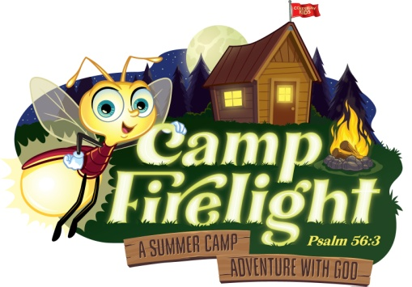
United Churches of Lycoming County
VACATION BIBLE SCHOOL

Camp Firelight

Sunday, July 21st – Thursday, July 25th
Held at Saint John’s-Newberry United Methodist Church
2101 Newberry Street, Williamsport

New!! Free Supper 5:30 – 6:00 p.m. – VBS 6:00 – 8:00 p.m. each evening
designed for ages 4 – 12 and special abilities adults

Registration Form (one form per child/person)

Child Name: ______________________________________________________________________________

Address: _________________________________________________________________________________

Emergency Contact Name: __________________________________ Relationship: ___________________

Email: ___________________________________________ Cell#: __________________________________

Age: ______ Grade Completed: ______ Church Affiliation: ___________________________________
New!! Attending the free nightly light supper: ____ Yes ____ No
What special needs/concerns/allergies do we need to be aware of to make this the best experience: __________________________________________________________________________________________

__________________________________________________________________________________________

Name of person who will be dropping off/picking up child: ____________________________________
Photo Release: Camp Firelight VBS has my permission to use my child’s photograph publicly in VBS materials. I understand the images may be used in print publications, online publications, presentations, websites, and social media. ____Yes ____ No
Photo Signature Acknowledgement ___________________________________________________
How did you hear about our VBS event? ________________________________________________

Please drop-off or mail information by Sunday, July 14th to any participating church or to the office of: Saint John’s-Newberry UMC, 2101 Newberry Street, Williamsport, PA 17701 or email to secretary@stjnumc.com
Participating Churches: Christ Episcopal, First Church of Christ Disciples, New Covenant UCC, Saint John’s-Newberry UMC, St. Luke and St. Mark’s Lutheran, Sojourner Truth Ministries and Trinity Episcopal

